 

Project Title: A CRM Application to Manage the Services offered by an Institution

## 1.Project Overview

This project is focused on CRM Application to Manage the Services offered by an Institution, designed to address the challenge of efficiently managing EduConsultPro Institute is a leading educational institution offering a variety of courses and programs in diverse fields. With a growing number of prospective students seeking admission each year, the institute faces challenges in managing the admission process, students enquiry, and expert consulting services efficiently. To address these challenges, EduConsultPro Institute decides to leverage Salesforce CRM to streamline the admission process and enhance the overall experience for both students and admissions staff.

Objectives:

1. **Streamline Admission Processes**: Automate and manage application submissions, tracking, and follow-ups.

2.**Enhance Student Experience**: Provide a seamless inquiry process and personalized communication.

3. **Data Management**: Centralize student data for better insights and reporting.

## Salesforce Key Features and Concepts Utilized

This highlights the main functionalities and concepts applied within the Salesforce project:

**AdmissionApplicationManagement:** Prospective students should have access to the admission application form through the institute's website or portal. The admission application form should collect comprehensive information including personal details, academic history, and qualification.

**ApprovalProcessRequirements:**Implement an Approval process in Salesforce to review and approve Consulting Request. Set up email alerts to notify relevant students when he/she is approved or rejected.

**ConsultingServicesManagement:**Prospective students should be able to request consulting services through the institute's website or portal. The consulting request form should capture student details, consulting preferences, and areas of expertise required. Submitted consulting requests should be recorded in the Salesforce CRM system.

**ImmigrationCaseManagement:**Students should be able to initiate immigration cases through the phone, email or web. The immigration case submission form should capture case details, and relevant information. Submitted immigration cases should be recorded and stored in the Salesforce CRM system.

## Detailed Steps to Solution Design

* **OBJECT:**

Navigate to Setup:

Go to the Setup page in Salesforce and click on Object Manager:

1.Create Course object:

1. Go to your object manager and and click on create object from spreadsheet
2. Click on the link to get the spreadsheet, [Course](https://docs.google.com/spreadsheets/d/1RD3chCZ1BWZxAKQxtntArr27K1iQxiNobeTA1iWe4Dc/edit#gid=613505717).
3. After downloading, upload the file, map the fields and upload to create an object.

**Create Remaining objects**

1. Follow the steps which we have followed for course object creation.
2. Use the following sheets for remaining objects.

[Consultant](https://docs.google.com/spreadsheets/d/12q_u-63PZ3MTCgJS1voKsvTL_jVIjW4kyI_9shgB97s/edit#gid=198933105)

[Student](https://docs.google.com/spreadsheets/d/1QbkK_l1K5x9aBN8LXrEZfYJ0qMMLU-5NTi5O3_cCe1Q/edit#gid=1705718850)

[Appointment](https://docs.google.com/spreadsheets/d/1Wvk7nWFXR7xn56F8kr1WQCYs5_x6_CUZsFiZtEpVufY/edit#gid=1793530912)

**Create Relationship among the objects**

1. Create lookup between appointment and student, appointment and consultant.
2. Create an object to store the information student and course details with the name Registration.
3. Also create a lookup between student and case to store the student queries for immigration or visa application.
4. The data model should be similar to the below Data Model with fields & relationships:
5. Create tabs for the respective object.

**Configure the Case Object**

1. 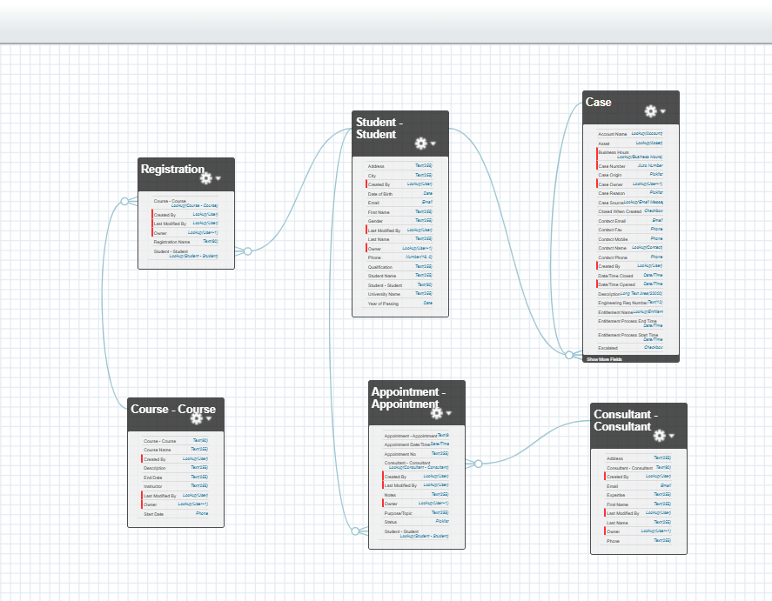Go to object manager, edit case object.
2. Select the “Type” field and add the values in it.  
   Immigration  
   Visa Application
3. Now Select the “Status” field and add the values in it.  
   Open  
   In-progress

**Create a Lightning App**

1. Go to Setup, search for the App Manager in quick find
2. Click on New Lightning App
3. Give app name as “EduConsultPro”, click Next, Next, Next
4. Add Home, Students, Courses, Consultants, Appointments, Registrations, and Cases from the Available Items to Selected Items.
5. Add “System Administrator” profile from Available Profiles to Selected Profiles, click Save & Finish

**2.Create a ScreenFlow for Student Admission Application process.**

**Add Screen Element:**

1. From Setup, enter Flow Builder in quick find, select new flow --> ScreenFlow.
2. Add a Screen element.
3. In the Screen Properties pane, for Label, enter “Student Info”.
4. Click on Fields, click on the record variable input and create a new Resource(StudentRecordRes) to display all the fields which are in the  student object. Drag all the fields which are needed to add on the screen inorder to collect the student information.

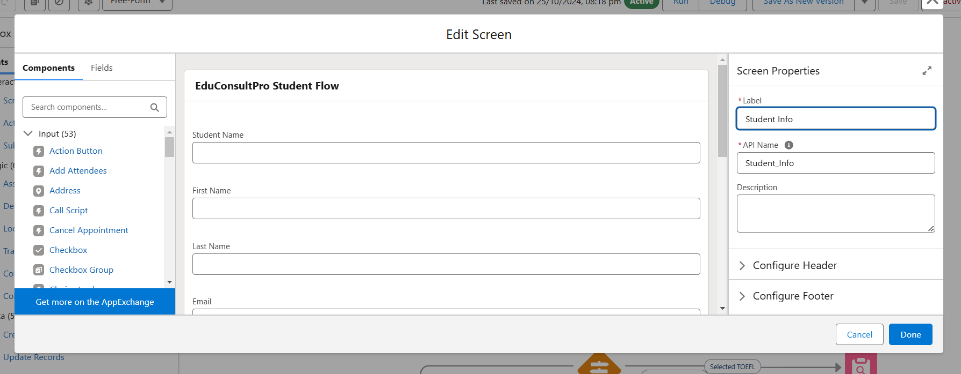

**Create Student Record using Create Element:**

1. Add a Create element after Student Info Screen Element, Label it as “Create Student Record.”
2. Select “one” under How many records to Create, and select “use all values from a record” under How to Set the record fields.
3. Select the record variable resource(StudentRecordRes) which we have created in the Student Info screen element, under Create a record from these values.

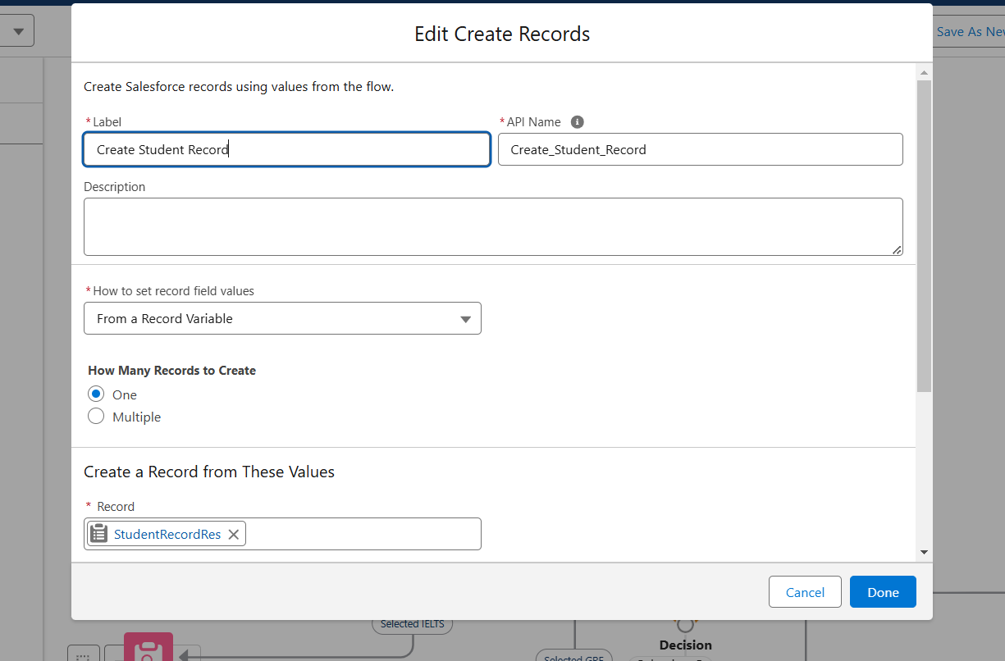

**Add Screen Element:**

1. Add a Screen Element after Create Student Record Element and label it as Course Screen.
2. Add a picklist component from the left side panel label it as “Select Course”, under choices type “IELTS” and enter. This creates a variable with the name IELTS.
3. Repeat the same for GRE, GMAT, Duolingo, TOEFL.

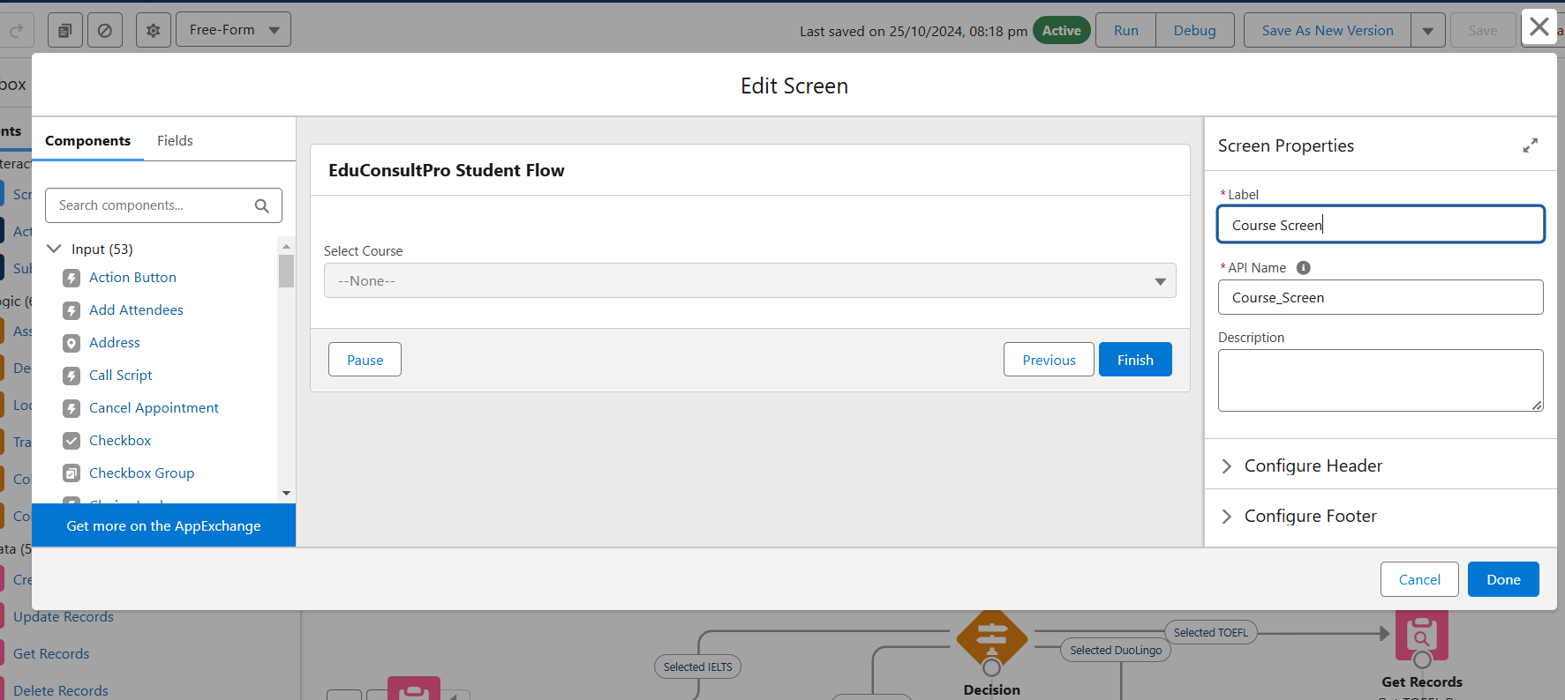

**Add Decision Element:**

1. Add a Decision Element after Select Course Screen Element, label it as Selecting Course.
2. Under outcome label it as “Selected IELTS” and write the condition such as below:  
   Resource : Select_Course (Screen Component from Select Course Screen Element)  
   Operator : Equals  
   Value : IELTS (Choice Variable from Select Course Screen Element)
3. Click on the “+” icon and Repeat step 2 for other options mentioned as below:
   1. GRE
   2. GMAT
   3. DuoLingo
   4. TOEFL
4. Click Done.

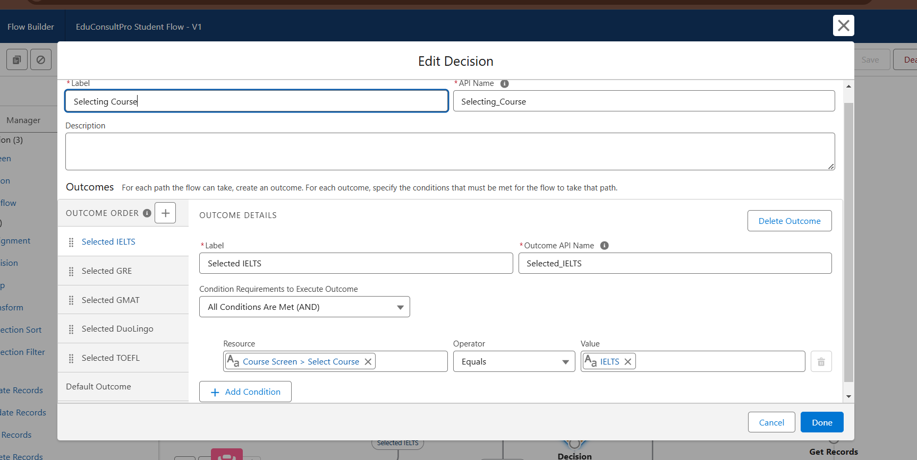

**Add GET Record Element:**

1. Add a GET Record Element after Decision Element, under the IELTS path and label it as “Get IELTS Rec”.
2. Select Object : Course  
   Condition Requirement : All Conditions are Met(AND)

Field : Course Name  
 Opertor : Equals  
 Value : {!Select_Course}

1. Repeat the steps 1 & 2 for the GRE, GMAT, TOEFL, DuoLingo paths.

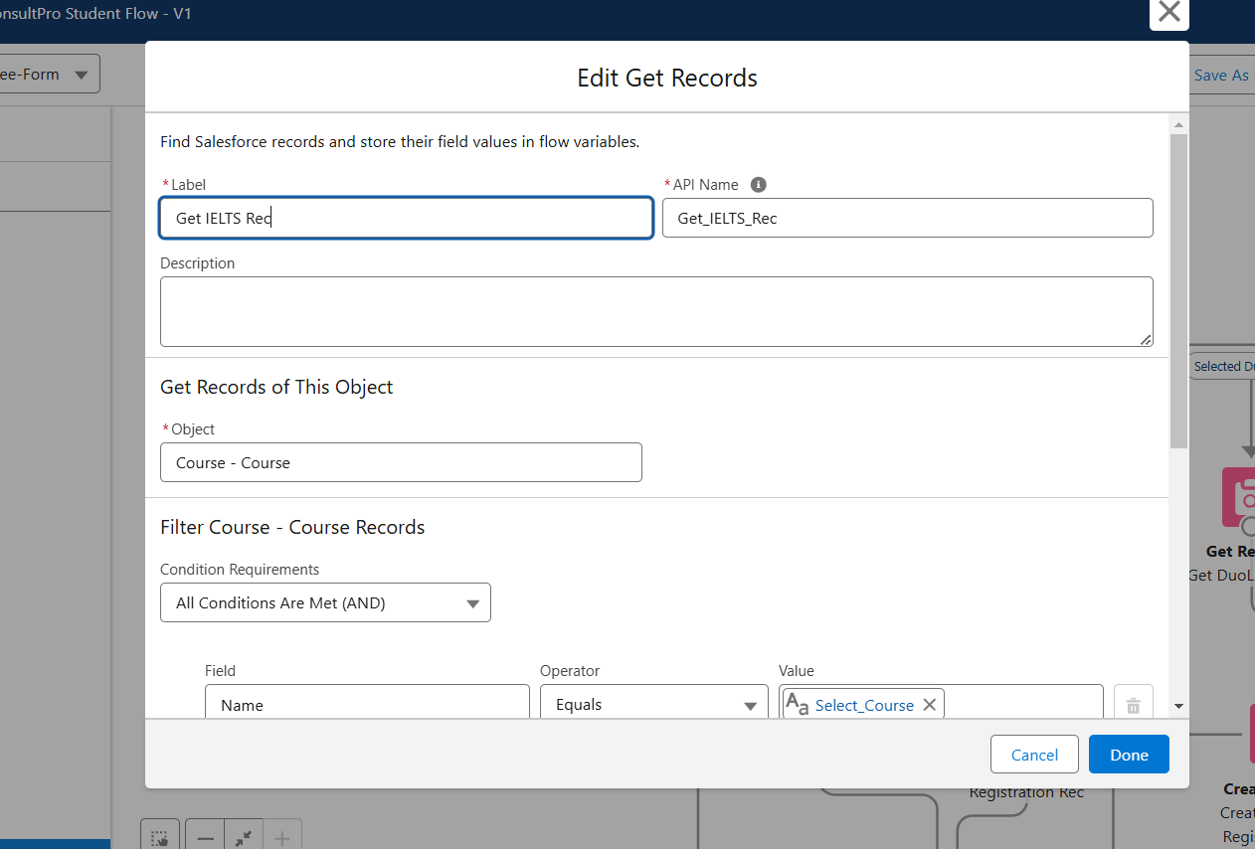

**Create Registration Record using Create Records Element**

1. Add a Create element after the Get IELTS Rec element and label it as “Create IELTS Registration Rec”.
2. Select “one” under How many records to Create, and select “Use separate resources, and literal values” under How to Set the record fields.
3. Select Object : Registration

Field : Course_Name__c  
 Value : {!Get_IELTS_Rec.Id}

Field : Student_Name__c  
 Value : {!StudentRecordRes.Id}

1. Repeat the steps 1 & 2 for the GRE, GMAT, TOEFL, DuoLingo paths.

**Create Email Text Template Variables for email body and subject**

1. Click on the toggle toolbox on the left corner, click “New Resource”, then select “Text Template” as Resource Type.
2. Give the API name as “StuRegistrationEmailTextTempBody”, select “view as plain text”  and paste the below text in body.

“Dear {!StudentRecordRes.Name},

Congratulations and welcome to EduConsultantPro!

We are delighted to inform you that your registration on our platform has been successfully completed. You are now part of our esteemed community dedicated to empowering students like you to achieve their educational and immigration aspirations.

At EduConsultantPro, we understand the importance of your academic and career goals, and we are committed to providing you with the highest level of support and guidance throughout your journey.

Here are a few key points to help you get started:

Explore Our Resources : Take some time to explore the wide range of resources, tools, and services available on the EduConsultantPro platform. From educational insights to immigration advice, we offer comprehensive support tailored to your needs.

Connect with Our Consultants : Our team of experienced consultants is here to assist you at every stage of your educational and immigration endeavors. Don't hesitate to reach out to us with any questions, concerns, or inquiries you may have. We're here to help!

Stay Updated : Keep an eye on your inbox for important updates, announcements, and exclusive opportunities from EduConsultantPro. We'll ensure that you're informed about the latest developments and relevant information to support your journey.

Engage with the Community : Join our vibrant community of students, professionals, and experts who share your passion for education and global opportunities. Connect with like-minded individuals, participate in discussions, and expand your network.

Once again, congratulations on taking this important step towards realizing your academic and career aspirations. We are thrilled to have you as part of the EduConsultantPro family and look forward to supporting you on your journey to success.

If you have any questions or need assistance, please don't hesitate to contact us.

Thank you.”

1. Click Done.
2. Repeat steps 1 & 2 to create an email text template for the email subject, label it as “StuRegistrationEmailTextTempSub”, write a text message in the body and save it.

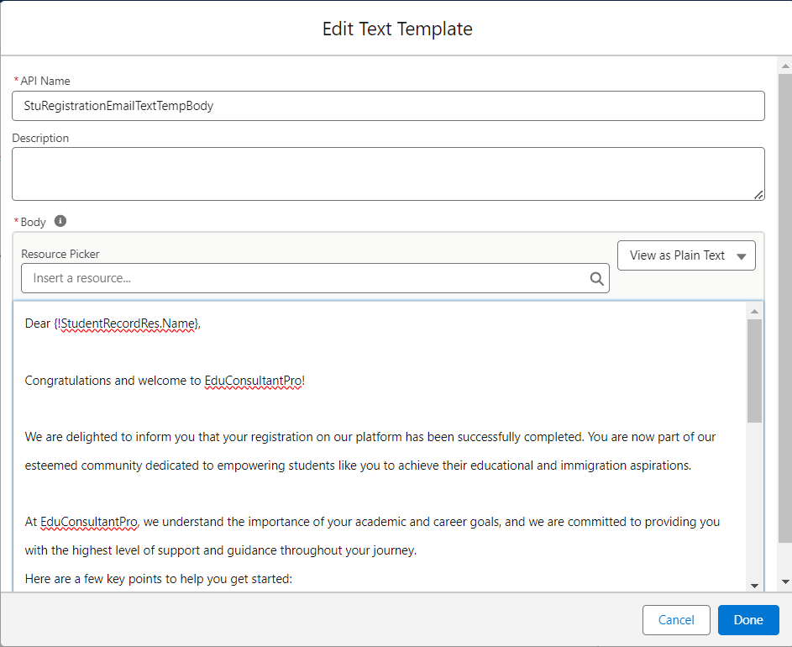

**Add an Action Element**

1. Add an Action Element after all the Decision paths, label it as “Send Email to Student”.
2. Under “Set input values for selected action”, include body, Recipient Address List and Subject.
3. For input Body : {!StuRegistrationEmailTextTempBody},  
   Recipient Address List : {!StudentRecordRes.Email__c},  
   Subject : {!StuRegistrationEmailTextTempSub}.

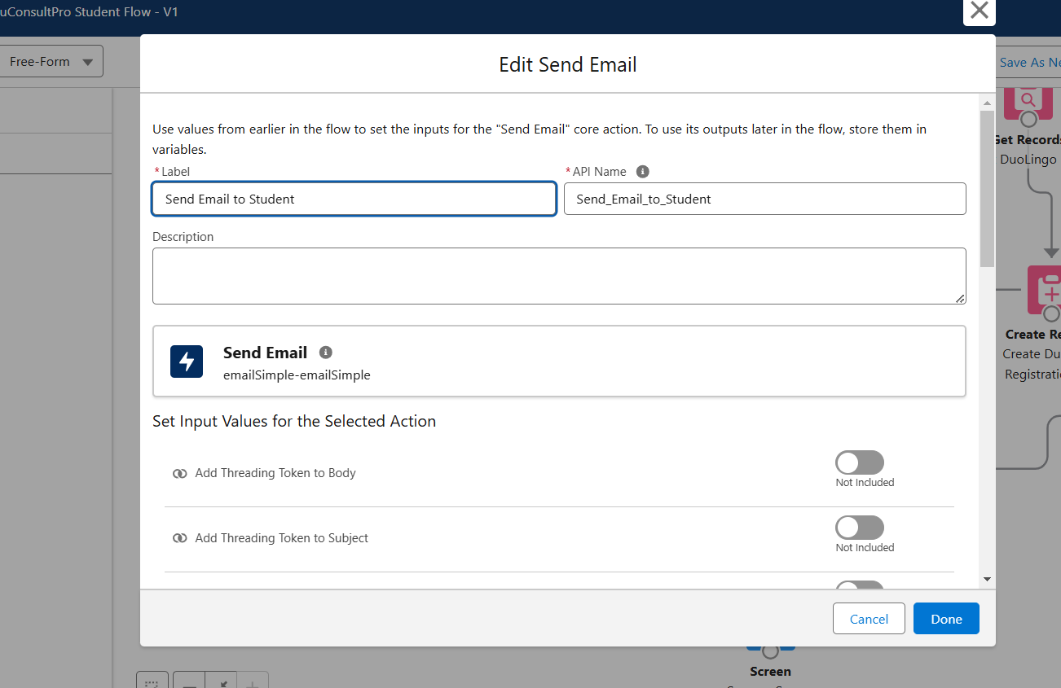

**Add Screen Element**

1. Add a Screen Element after the Send Email to Student Action Element, label it as Success Screen.
2. From the left side panel search for the Display text component and drag it to the main panel, label it as “SuccessMessage”.
3. Paste the below in the Resource picker box.

“Dear {!StudentRecordRes.Name},

Congratulations and welcome to EduConsultantPro!

We are delighted to inform you that your registration on our platform has been successfully completed. You are now part of our esteemed community dedicated to empowering students like you to achieve their educational and immigration aspirations.

Your Registration details have been sent through mail kindly check it once.  
Thank you.”

1. Click Done.
2. Save the flow and name it as “EduConsultPro Student Flow”. Your flow will look as shown below:

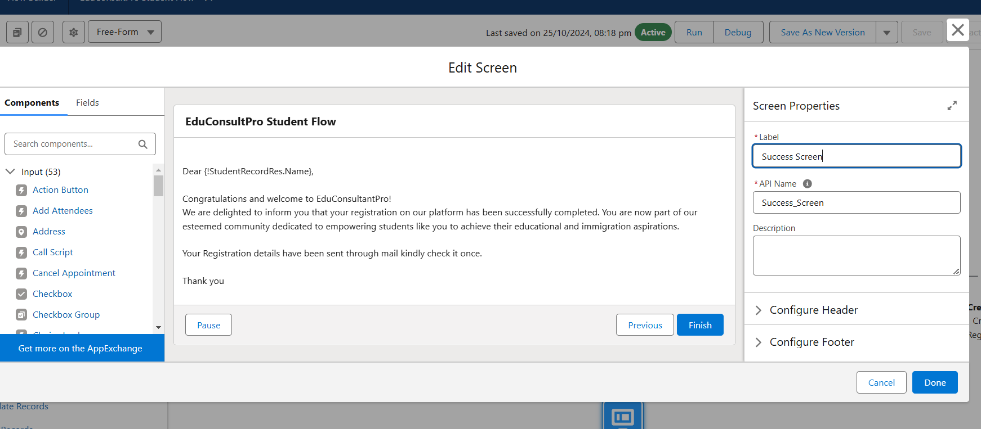

**3.Create Users**

**Create a user with a Standard platform user profile.**

**User**

1. Go to Setup --> Administration --> Users --> New User
2. LastName  : Consultant
3. License : Salesforce Platform
4. Profile : Standard Platform User
5. Fill all the mandatory fields & Save.

**Configure the User Settings**

1. Go to Setup --> Administration --> Users --> click Edit next to your name
2. Scroll down to bottom, under Approver Settings, Select “Consultant” the Manager Field.
3. Click Save.

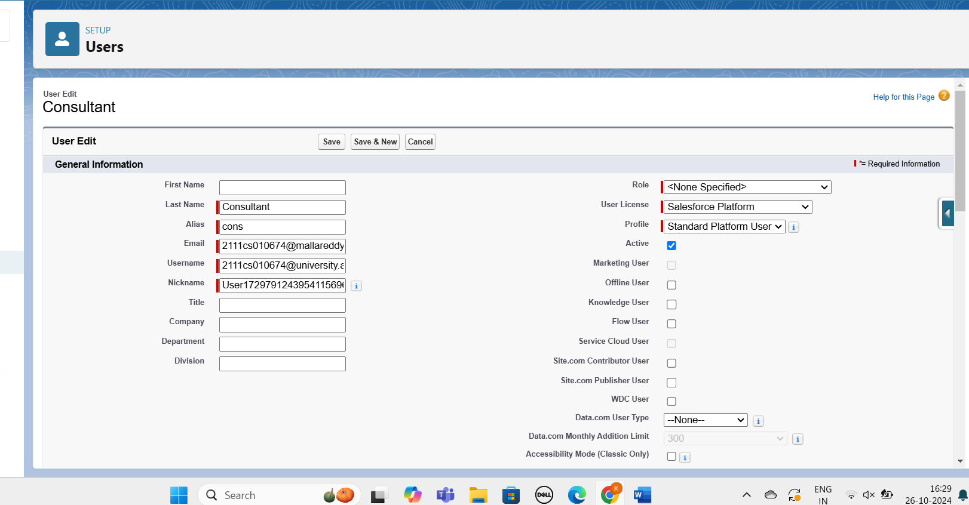

**4.Create an Approval Process for Property Object**

**Create an Email Template**

1. From Setup, enter Templates in the Quick Find box, and then select Lightning Email Templates, toggle on.
2. go to app launcher, search for “Email Templates”, Create a new folder with the desired name.
3. Then create a new email template, select the folder which we have created in the previous steps, enter the below text in the HTML Value and Save it as "Submission Template".

"Dear {{{Appointment__c.Student_Name__c}}},I hope this email finds you well. I am writing to confirm the details of our upcoming appointment scheduled for {{{Appointment__c.Appointment_DateTime__c}}} regarding {{{Appointment__c.PurposeTopic__c}}}.

Appointment Details:  
Appointment No : {{{Appointment__c.Name}}},  
Student Name : {{{Appointment__c.Student_Name__c}}},  
Consultant Name : {{{Appointment__c.Consultant__c}}},  
Date & Time : {{{Appointment__c.Appointment_DateTime__c}}},  
Purpose : {{{Appointment__c.PurposeTopic__c}}}

I want to assure you that I am looking forward to our meeting and am fully prepared to address any questions or concerns you may have regarding {{{Appointment__c.PurposeTopic__c}}}. Your success and satisfaction are my top priorities, and I am committed to providing you with the guidance and support you need.

If you have any specific topics or questions you would like to discuss during our appointment, please feel free to share them with me in advance. This will help ensure that our time together is as productive and beneficial as possible.

If for any reason you need to reschedule or cancel our appointment, please notify me at your earliest convenience so that we can make alternative arrangements.

Once again, thank you for choosing to work with me on this matter. I am confident that our collaboration will lead to positive outcomes and progress toward your goals.If you have any questions or require further information before our scheduled appointment, please don't hesitate to reach out to me.

Looking forward to our meeting.

Best regards,

{{{Recipient.Name}}},  
EduConsultantPro"

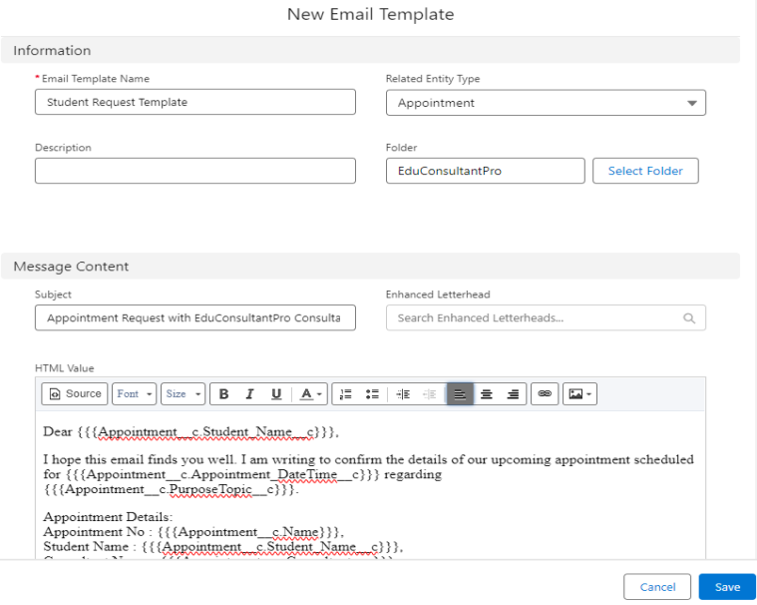  
4. Create two more Email templates for Approval and Rejection of Request similar to the previous one.

**Create an Approval Process**

1. From Setup, enter Approval in the Quick Find box, and then select Approval Processes.
2. In Manage Approval Processes For, select Appointment.
3. Click Create New Approval Process --> Use Jump Start Wizard.
4. Configure the approval process.
5. Process Name - Appointment Approval, Under Select Approver, Select Manager for the option : “Automatically assign an approver using a standard or custom hierarchy field.”
6. Click next and “Next Automated Approver Determined By” --> Select Manager.
7. From Record Editability Properties --> Click on Administrators OR the currently assigned approver can edit records during the approval process.
8. Save the approval process.
9. Click View Approval Process Detail Page.

10.Under Initial Submission Actions, click Add New --> Field Update, and configure it with these values.

|  |  |
| --- | --- |
| Field | Value |
| Name | Submitted |
| Field to Update | Appointment: Status |
| A Specific value | Pending |

1. click Add New --> Email Alert, and configure it with these values.  
   Description : Submission Email Alert  
   Unique Name : Auto Populates  
   Email Template : Submission Template  
   Recipient Type : Select your Name
2. Repeat the Steps 10 - 11 for Final Approval and Final Rejection actions.

**5.Create a Record Triggered Flow**

**Configure the Start Element**

1. From Setup, enter Flows in the Quick Find box, then select Flows.
2. Click New Flow.
3. Select Record-Triggered Flow.
4. Click Create. The Configure Start window opens.
5. For Object, select Appointment.
6. For Trigger the Flow When, select A record is created. The flow will look like this:

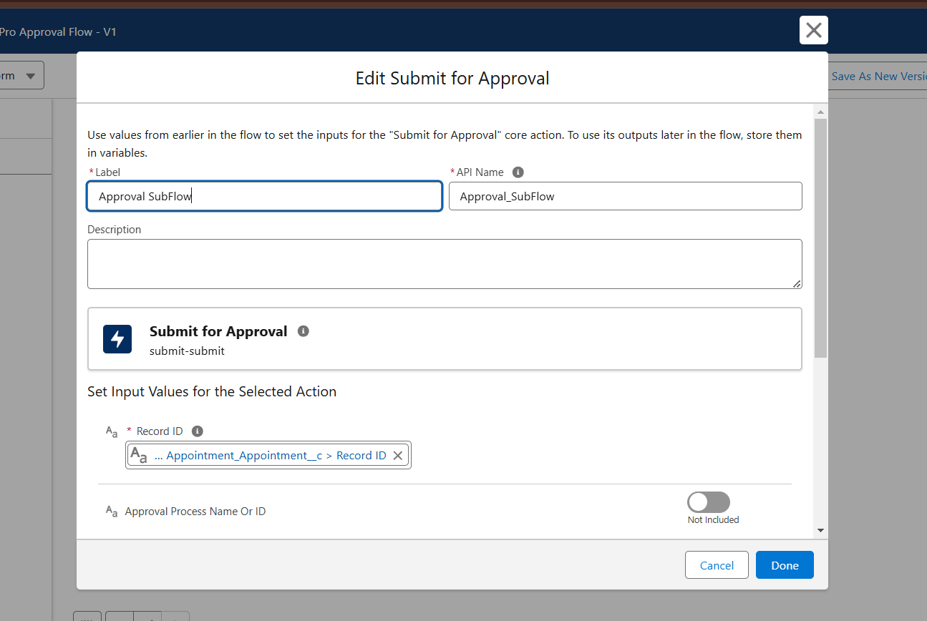

**Add an Action Element**

1. Add an Action element after the Start Element and Select the Submit for approval action, label it as “Approval SubFlow”.
2. Set the RecordId to “{!$Record.Id}”.
3. Save the Flow, label it as "EduConsultPro Approval Flow and Click on Activate.

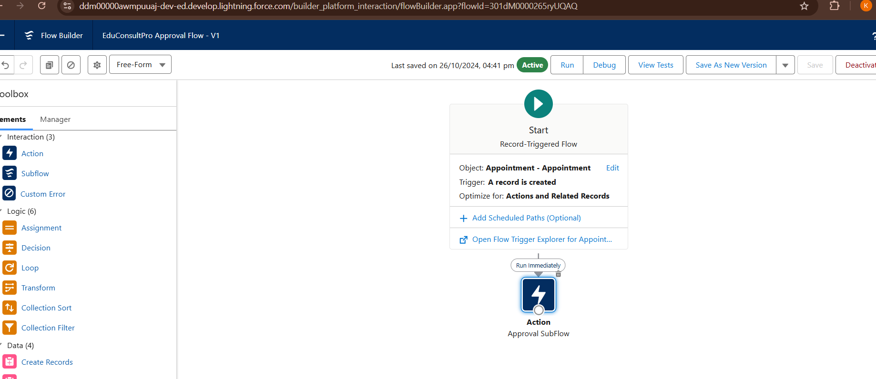

**6.Create a ScreenFlow for Existing Student to Book an Appointment**

**Add Screen Element**

1. From Setup, enter Flow Builder in quick find, select new flow ? ScreenFlow.
2. Add a Screen element.
3. In the Screen Properties pane, for Label, enter “Get Student Info”.
4. Add two Text components from the left side panel. Give the Label’s as follows:  
   1st Text Component Label : Enter Student Name  
   2nd Text Component Label : Enter Student Email
5. Click on Done.

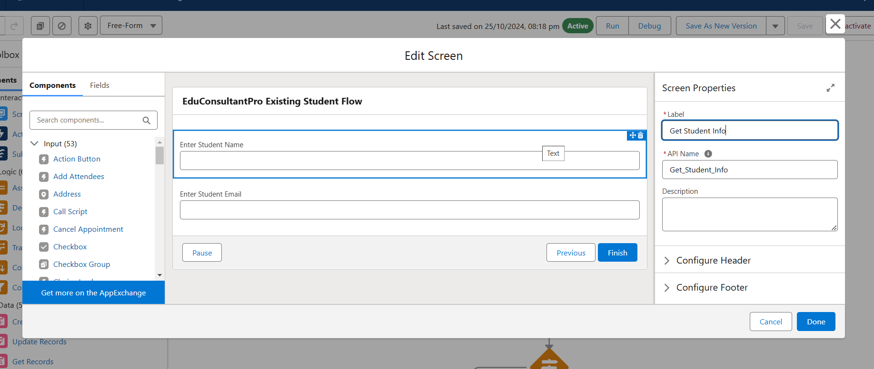

**Add GET Record Element**

1. Add a GET Record Element after Decision Element, under the IELTS path and label it as “Get Rec”.
2. Select Object : Student  
   Condition Requirement : All Conditions are Met(AND)
   1. Field : Student Name  
      Operator : Equals  
      Value : {!Enter_Student_Name}
   2. Field : Email__c  
      Operator : Equals  
      Value : {!Enter_Student_Email}

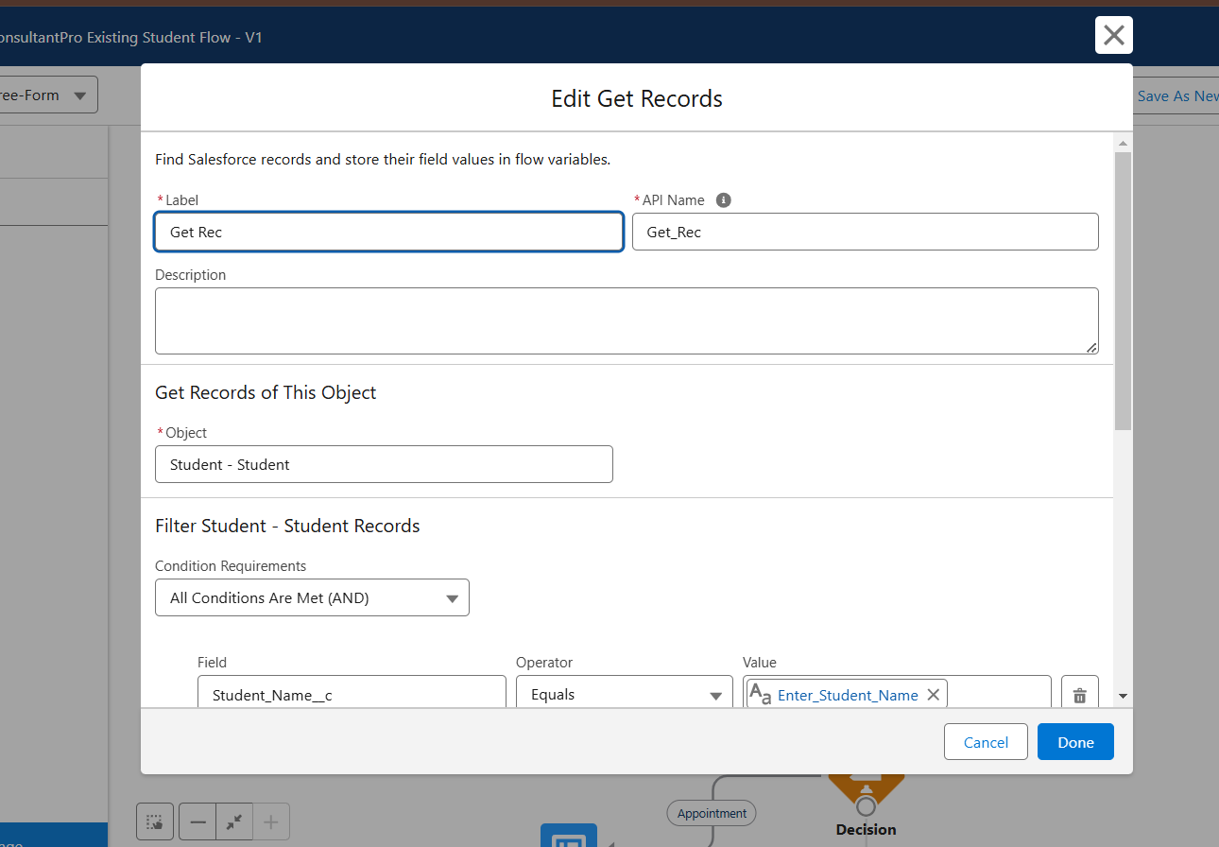

**Add Decision Element**

1. Add a Decision Element after Select Display Student Details Element, label it as “Appointment or Case”.
2. Under outcome label it as “Appointment” and write the condition such as below:  
   Resource : {!How_may_I_Help_you}  
   Operator : Equals  
   Value : {!Book_an_Appointment}
3. Click on the “+” icon and Repeat step 2 for Case options mentioned.

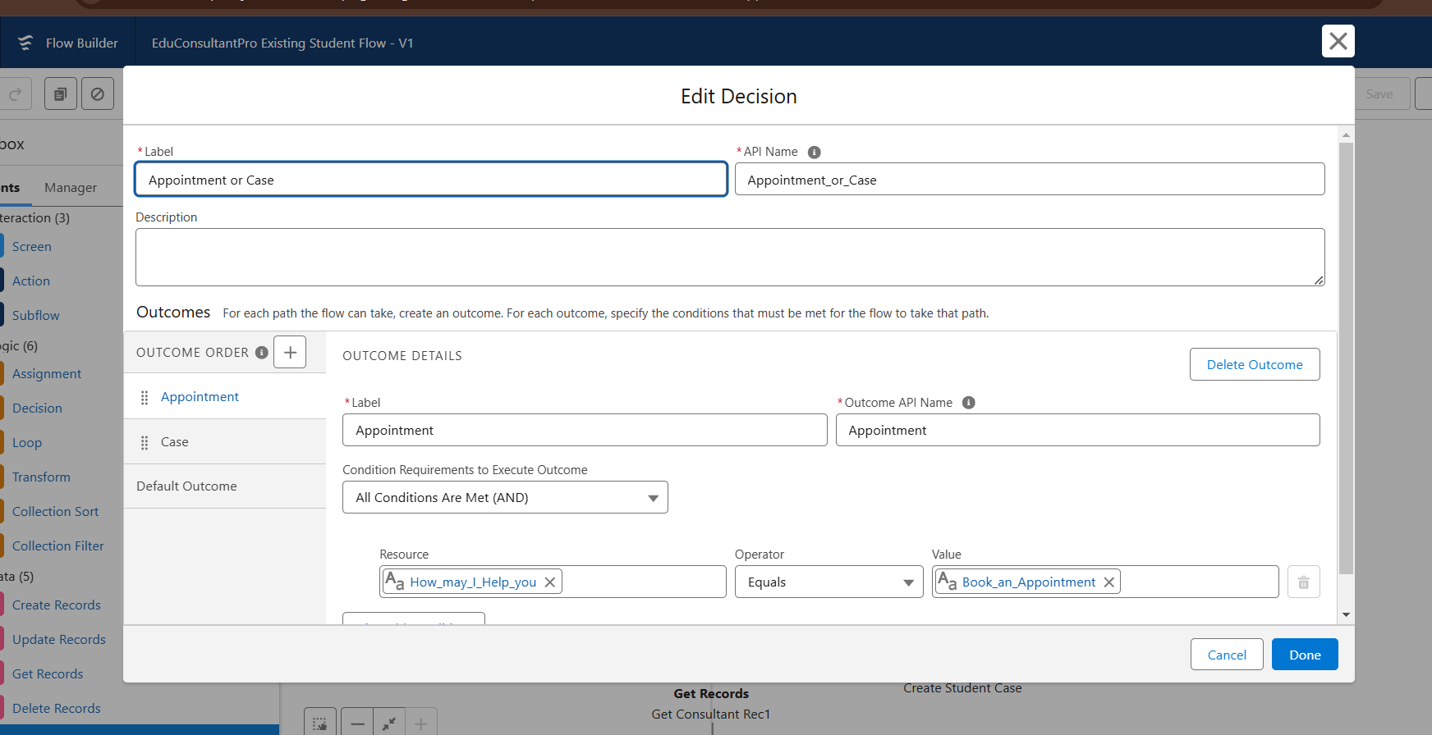

**Add Screen Element**

1. Add a Screen element after the Decision Element, on the Appointment path and label it as “Appointment Booking Screen".
2. Click on Fields, click on the record variable input and create a new Resource (AppointmentRecordRes) to display all the fields which are in the  Appointment object.
3. Drag all the fields which are needed to add on the screen inorder to collect the student information.

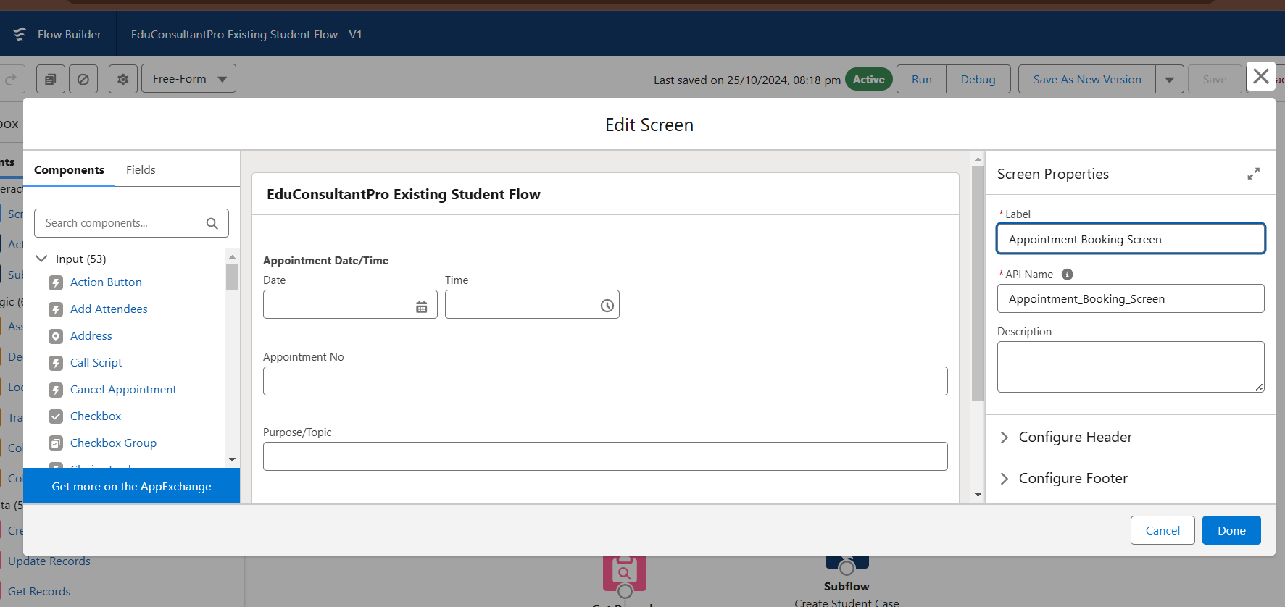

4.Click Done.

**Add GET Record Element**

1. Add a GET Record Element after Decision Element, under the Appointment path and label it as “Get Consultant Rec”.
2. Select Object : Consultant  
   Condition Requirement : All Conditions are Met(AND)
   1. Field : Name  
      Operator : Equals  
      Value : {!AppointmentRecordRes.Consultant_Name__c}

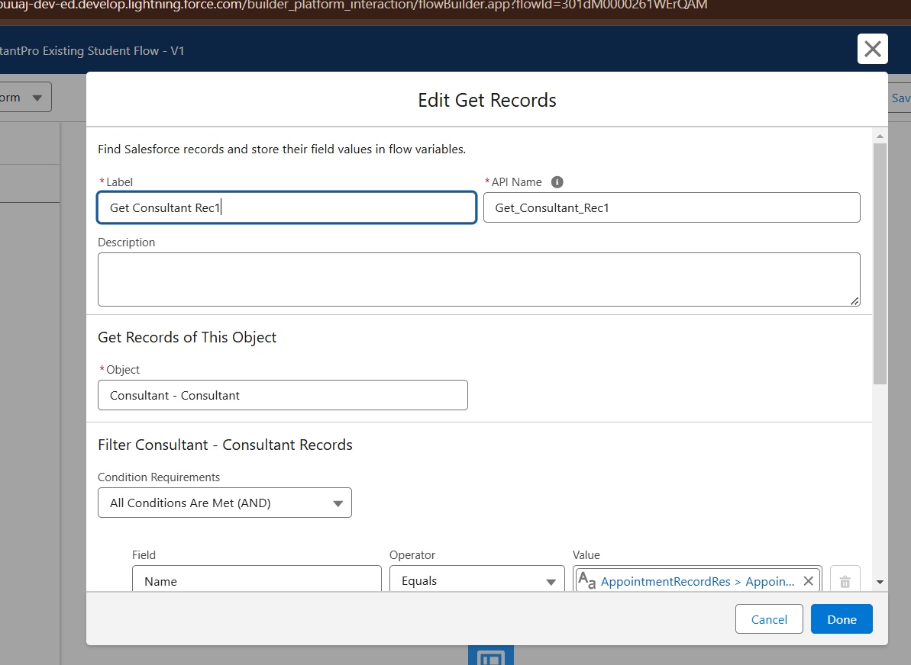

**7.Create Appointment Record using Create Records Element**

1. Add a Create element after the Get Consultant Rec element and label it as “Create Appointment”.
2. Select “one” under How many records to Create, and select “Use separate resources, and literal values” under How to Set the record fields.
3. Select Object : Appointment
   1. Field : Appointment_DateTime__c  
      Value : {!AppointmentRecordRes.Appointment_DateTime__c}
   2. Field : Consultant__c  
      Value : {!Get_Consultant_Rec.Id}
   3. Field : Notes__c  
      Value : {!AppointmentRecordRes.Notes__c}
   4. Field : PurposeTopic__c  
      Value : {!AppointmentRecordRes.PurposeTopic__c}
   5. Field : Student_Name__c  
      Value : {!Get_Rec.Id}

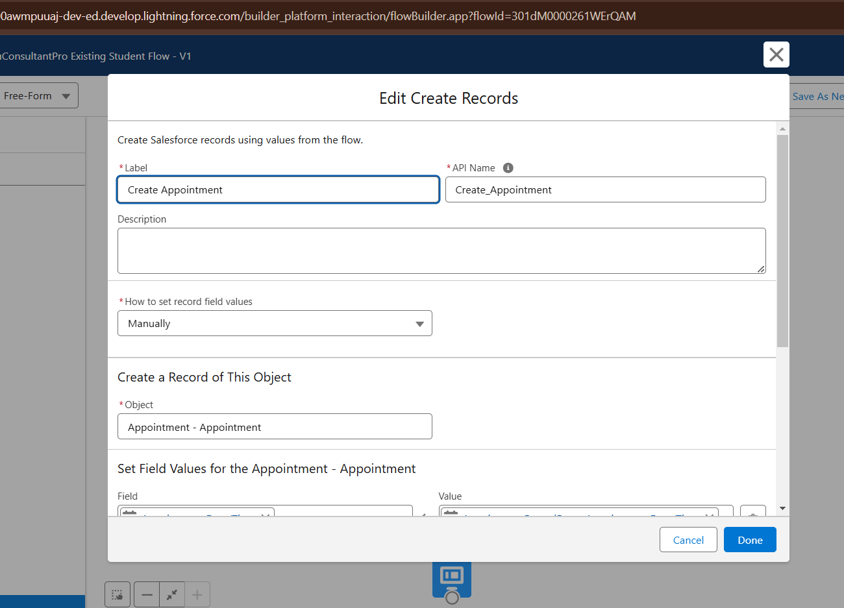

**Add Screen Element**

1. Add a Screen Element after the Send Email to Student Action Element, label it as “Confirmation Screen”.
2. From the left side panel search for the Display text component and drag it to the main panel, label it as “Appointment_Confirmation”.
3. Paste the below in the Resource picker box.

Consultant Name : {!Get_Consultant_Rec.Name},

Date & Time :  {!AppointmentRecordRes.Appointment_DateTime__c},

Notes : {!AppointmentRecordRes.Notes__c}

1. Click Done.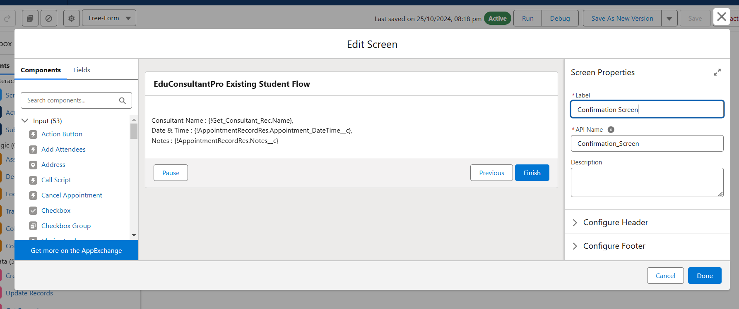

**Add an SubFlow Element**

1. Add a subflow element after the Decision Element, on the Case path and search and Select for “Create a Case”, label it as “Create Student Case”.
2. Save the flow and label it as “EduConsultantPro Existing Student Flow”, you can use the below image for reference.

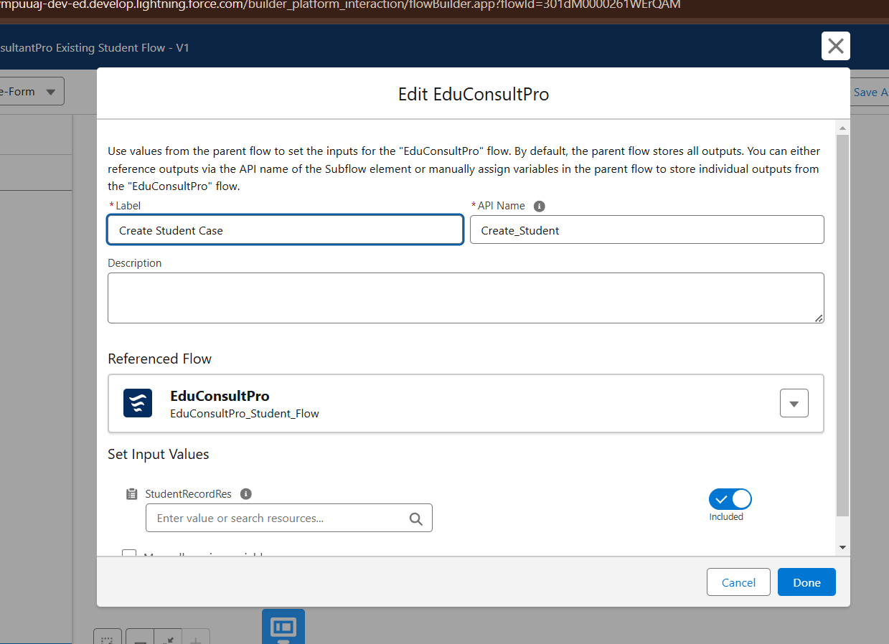

**8.Create a ScreenFlow to Combine all the flows at one place**

**Add Screen Element**

1. Add a Screen Element and label it as Welcome Screen.
2. From the left side panel search for the Display text component and drag it to the main panel, label it as “SuccessMessage”.
3. Paste the below in the Resource picker box.

“Welcome to EduConsultantPro

*your premier destination for education and immigration solutions!*

At EduConsultantPro, we understand that embarking on educational or immigration journeys can be both exhilarating and daunting. That's why we're here to guide you every step of the way with expertise, dedication, and personalized support.

Whether you're seeking to pursue your academic dreams abroad, navigate the complexities of immigration processes, or enhance your professional skills through international opportunities, EduConsultantPro is your trusted partner.Our team of seasoned consultants is committed to understanding your unique aspirations and crafting tailored strategies to help you achieve your goals efficiently and effectively. From selecting the right educational institution to navigating visa procedures, our comprehensive services cover all aspects of your journey.

At EduConsultantPro, we believe in fostering inclusive communities and unlocking the full potential of every individual. With our unwavering commitment to excellence and integrity, we strive to make your experience with us seamless and rewarding.

Welcome to EduConsultantPro – where your aspirations meet our expertise, and together, we pave the path to success. Let's embark on this transformative journey together!”

1. Click Done.

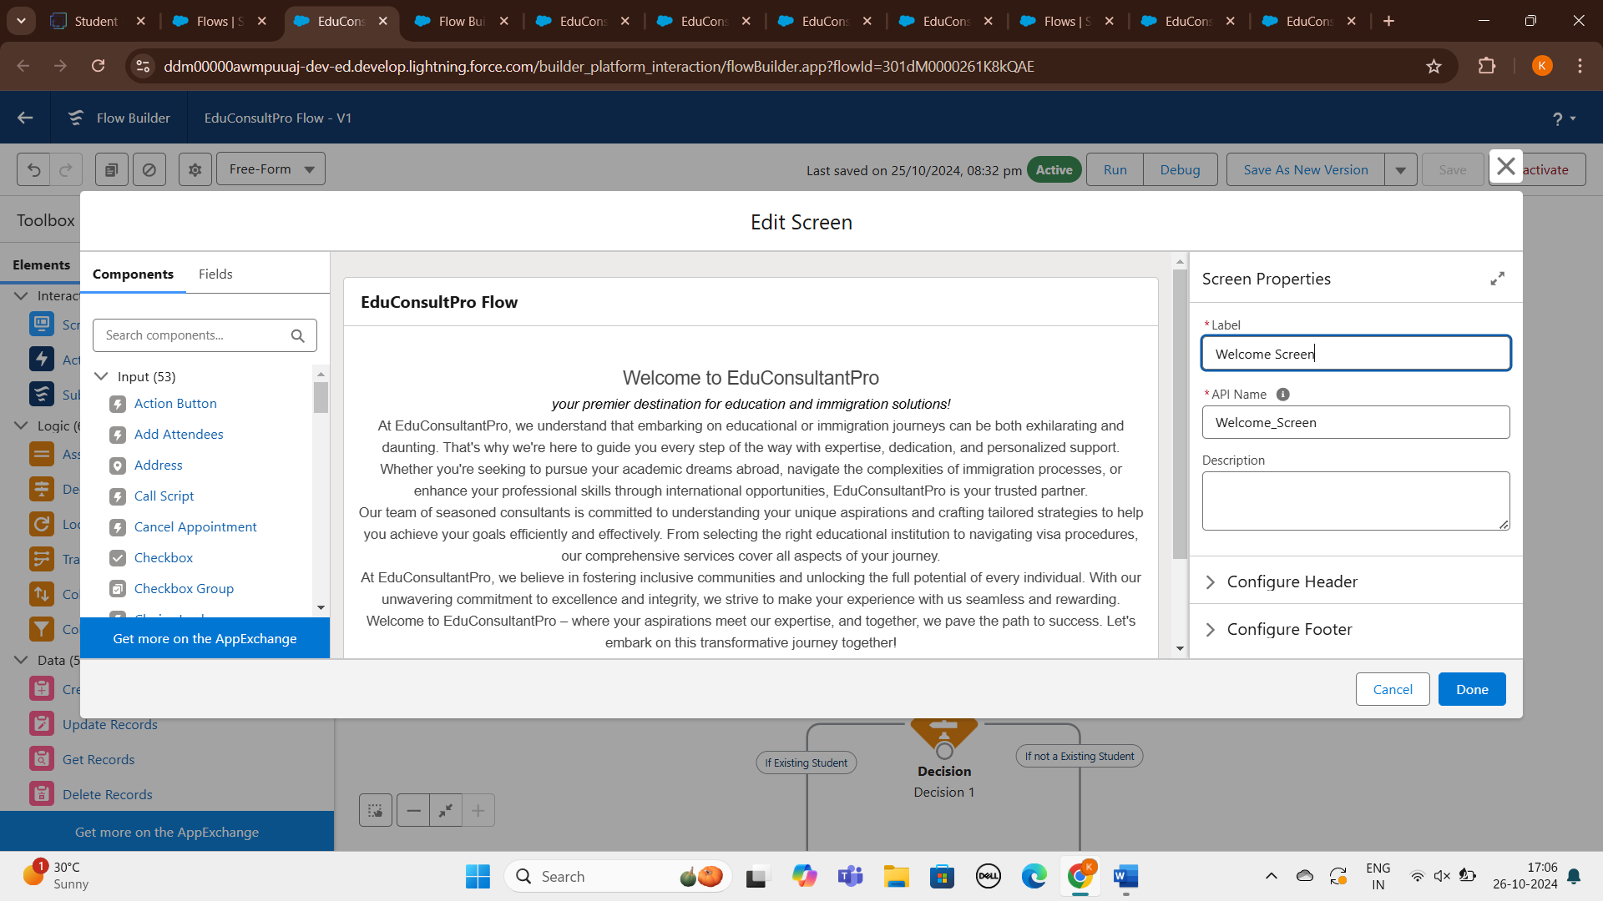

**Add Screen Element**

1. Add a Screen Element after the Welcome Screen Element, label it as “Existing or New Student Confirmation Screen”.
2. Add a radio button component from the left side panel,  
   label : Are you a Existing Student
3. Click on Add Choice --> type “Yes” in the input field --> click Create Yes choice.
4. Repeat step 6 and create an “No” choice resource.
5. Click Done.

**Add Decision Element**

1. Add a Decision Element after Existing or New Student Confirmation Screen Element, label it as “Decision 1”.
2. Under outcome label it as “If Existing Student” and write the condition such as below:  
   Resource : {!Are_you_a_Existing_Student}  
   Operator : Equals  
   Value : {!Yes}
3. Click on the “+” icon and Repeat step 2 for No options mentioned.

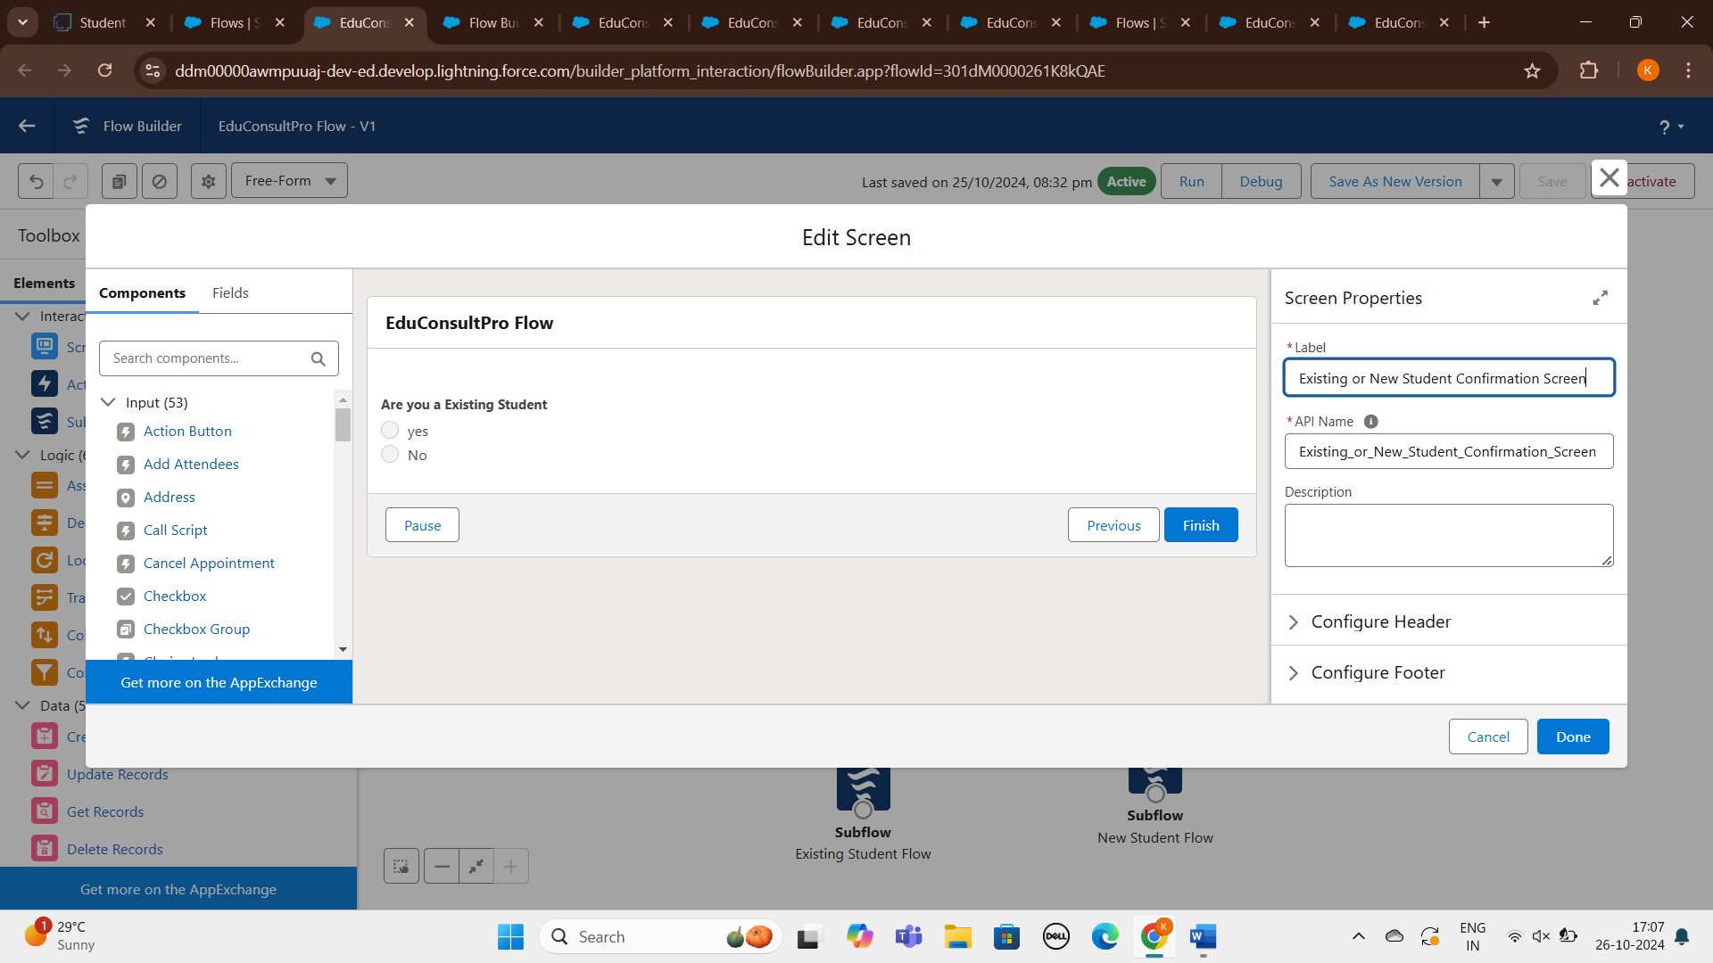

**Add an SubFlow Element**

1. Add a subflow element after the Decision 1 Element on the if Existing Student path and search and Select for “EduConsultantPro Existing Student Flow '', label it as “Existing Student Flow”.
2. Save the flow and label it as “EduConsultantPro Existing Student Flow”.
3. Click Done.

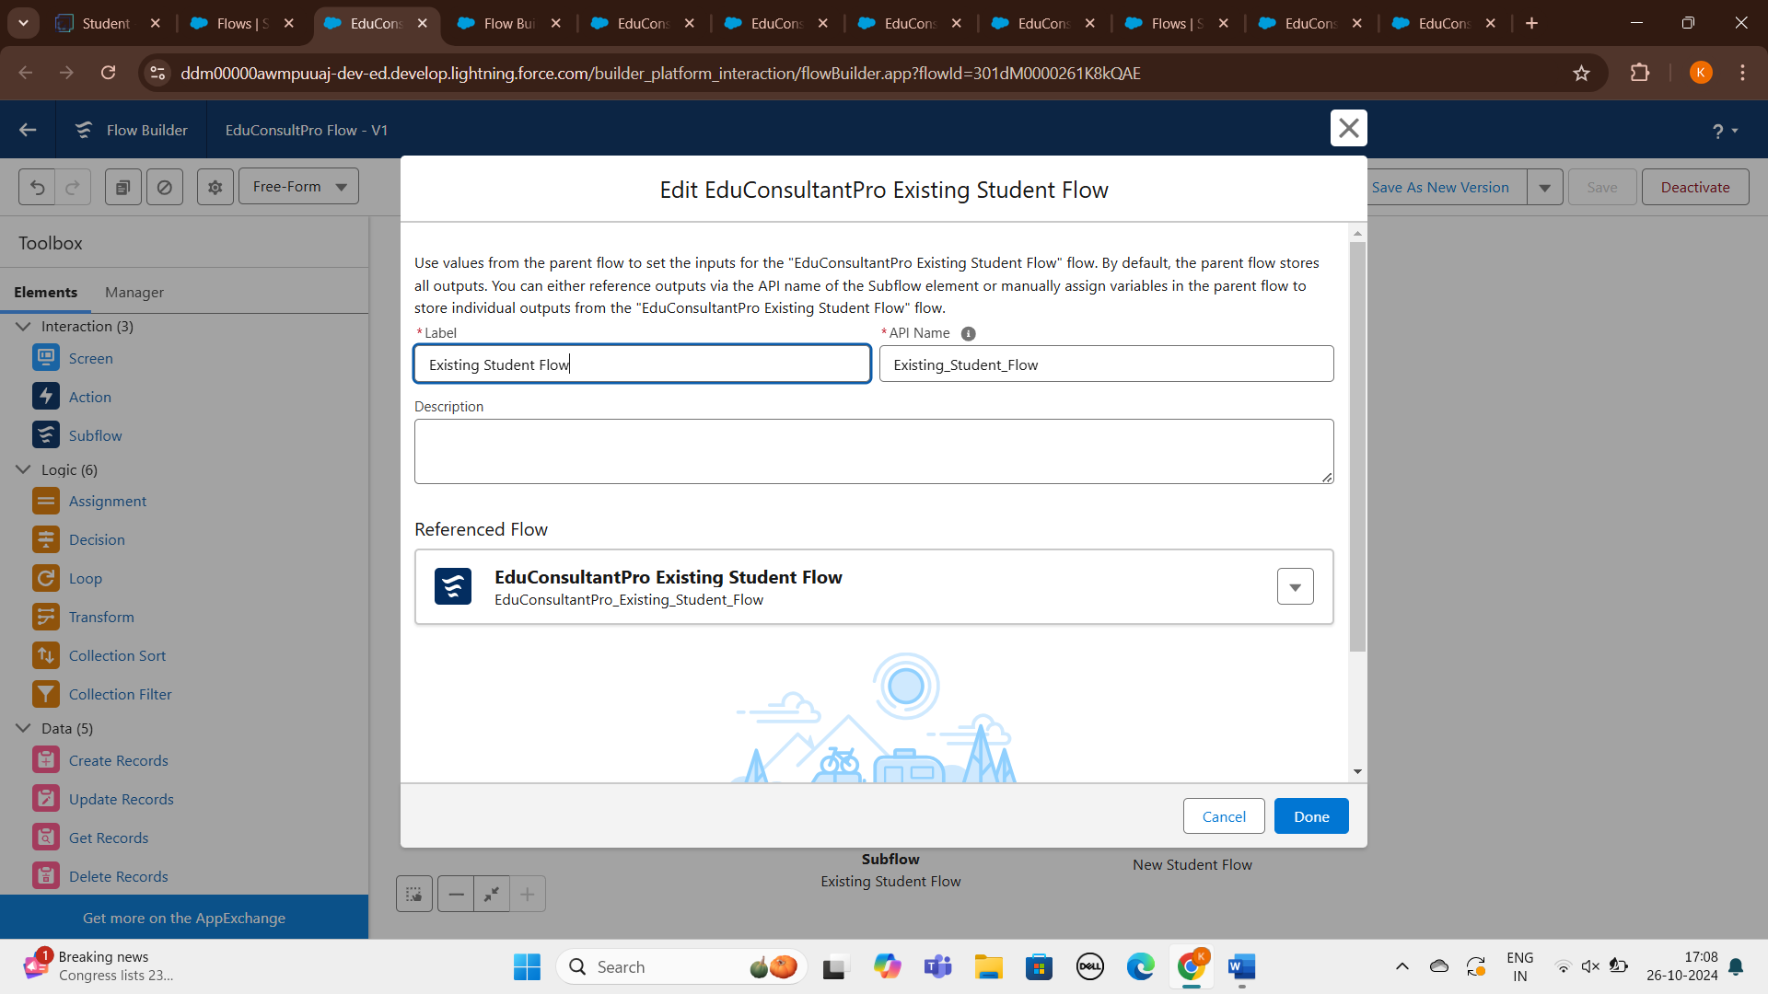

**Add an SubFlow Element**

1. Add a subflow element after the Decision 1 Element on the if Not an Existing Student path and search and Select for “EduConsultantPro Student Flow '', label it as “New Student Flow”.
2. Save the flow and label it as “EduConsultantPro Existing Student Flow”.
3. Click Done.
4. Save the flow and label it as “EduConsultPro Flow”, you can use the below image for reference.

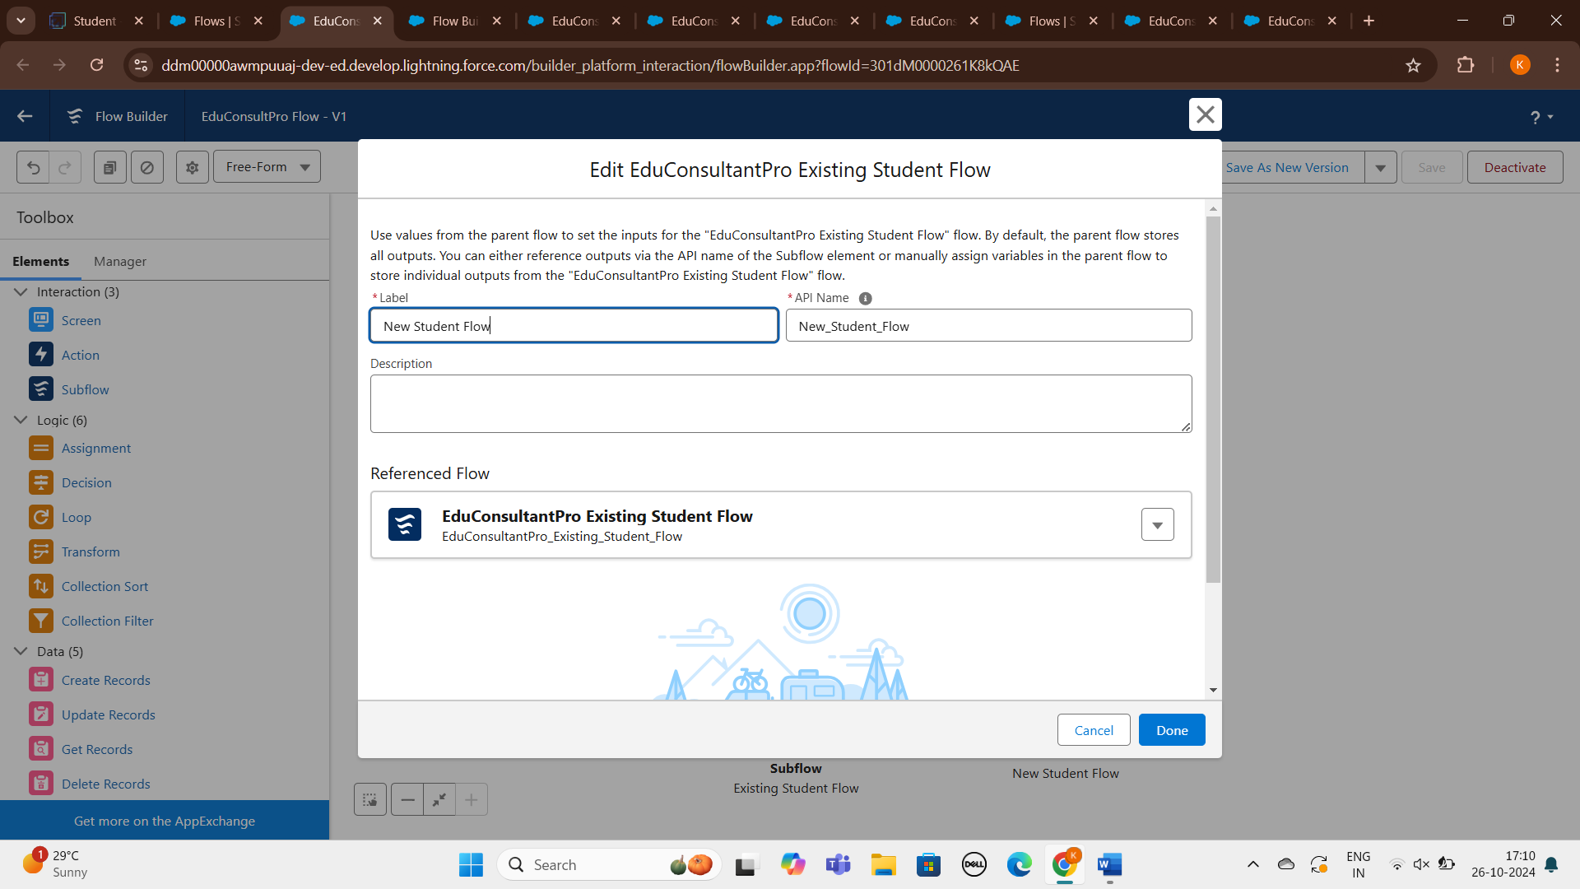

**9.Create a lightning app page**

Create a lightning app page and make it available at the application

**Create a lightning app page**

1. From Setup, enter App Builder in the Quick Find box, then click Lightning App Builder.
2. Click New, select Home Page, then click Next.
3. Step through the wizard and name the page “EduConsultPro Home Page”, select the Standard Home Page template, and then click Done.
4. Drag the Flow component to the top-right region.
5. Search for the “EduConsultantPro Flow” and click Save.
6. Click Activate, Click App and Profile, then click Assign to Apps and Profiles.
7. Select the Sales app, then click Next.
8. Scroll down the list of profiles and select System Administrator, then click Next.
9. Review the assignment, and then click Save.

**Conclusion:**

The use case focuses on the admission process for prospective students interested in enrolling in

courses and programs offered by EduConsultPro Institute. The goal is to provide a seamless and

transparent experience for students while enabling admissions staff to efficiently review and process

admission applications, students enquiry and case management**.**

